Final Challenge on Terraform-3
1) Create VPC
Created a Virtual Private Cloud (VPC) with CIDR block 10.0.0.0/16 to
provide an isolated network environment for AWS resources.
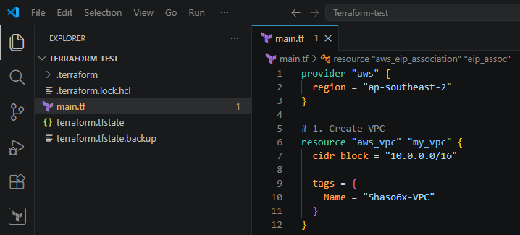
2) Create Internet gateway
Created and attached an Internet Gateway (IGW) to the VPC to enable
communication between resources in the VPC and the internet. 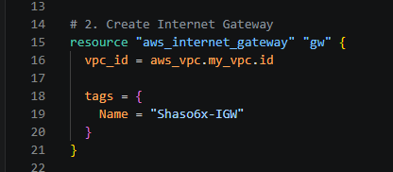
3) Create Custom Route Table
Created a custom route table and added a route 0.0.0.0/0 pointing to the
Internet Gateway, allowing outbound internet access. 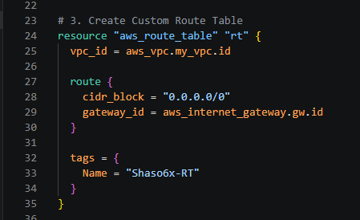
4) Create Subnet
Created a subnet with CIDR block 10.0.1.0/24 within the VPC to host
AWS resources such as EC2 instances. 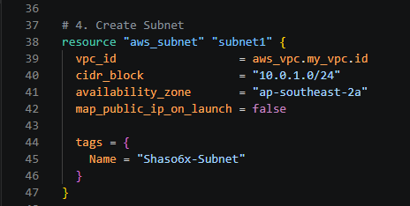
5) Associate subnet with Route Table
Associated the subnet with the custom route table to ensure that
resources in the subnet use the defined routing rules. 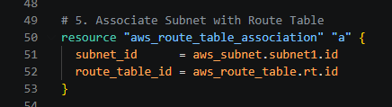
6) Create Security Group to allow port 22.80,443
Created a security group that allows:
Port 22 (SSH) for remote administration.
Port 80 (HTTP) for web traffic.
Port 443 (HTTPS) for secure web traffic.
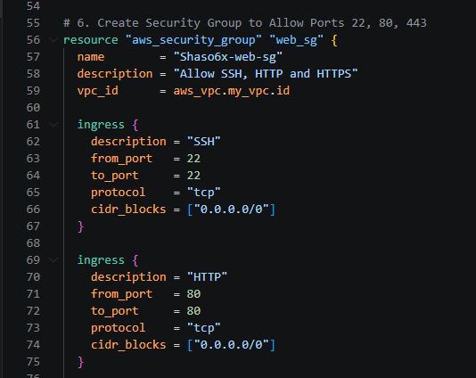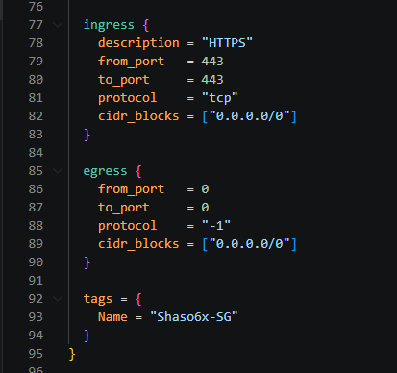
7) Create a network interface with an ip in the subnet that was
created in step 4
Created an Elastic Network Interface (ENI) in the subnet and assigned a
private IP address (10.0.1.50). The ENI was associated with the security
group to control network traffic.
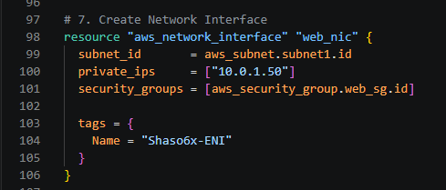
8) Assign an elastic IP to the network interface created in step 7
Allocated an Elastic IP (EIP) and associated it with the network
interface to provide a static public IP address for internet accessibility.
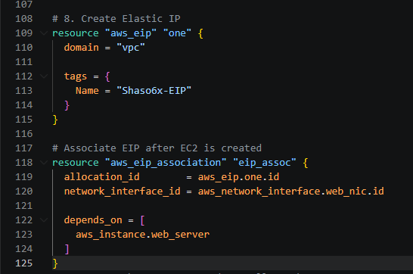
9) Create Ubuntu server and install/enable apache2
Launched an Ubuntu EC2 instance, attached the network interface, and
used a user data script to install, start, and enable Apache2
automatically during instance boot.
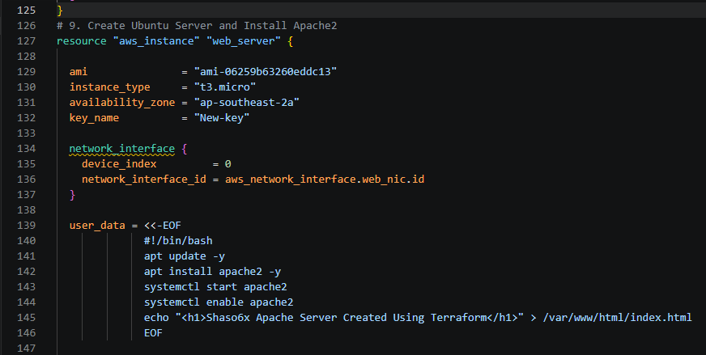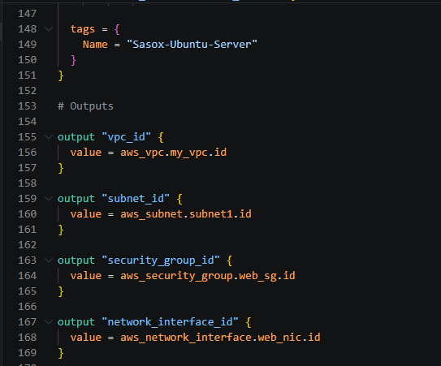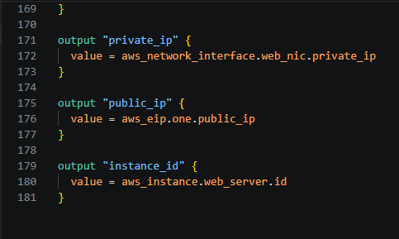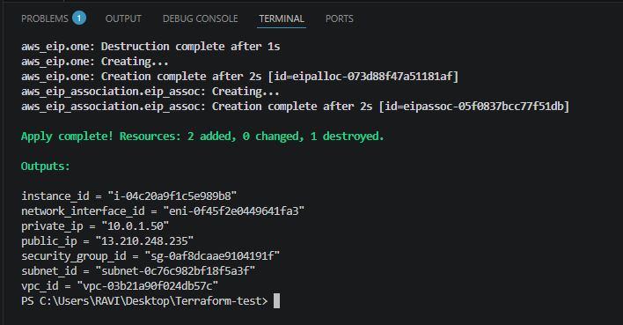
Verified in the browser
